Continuing Professional Education Events 2016
Dear Colleague,
Listed below is a special CPE workshop that will be coming up in February and repeated in March and July 2016. Please refer to the online calendar for further information about all the events being planned for 2015. http://www.ridbc.org.au/renwick/calendar-events
Reach & Match® Inclusive Learning Program: Fun for All
Presentation & Workshop: Reach & Match® Inclusive Learning Program: Fun for All
When: Wednesday 17 February 2016 4:30-6:00pm
Presenter: Mandy Lau, Founder & Designer of Reach & Match® Learning Kit
Fee: $20 includes afternoon tea (refundable for any purchase of Reach & Match®)

Description

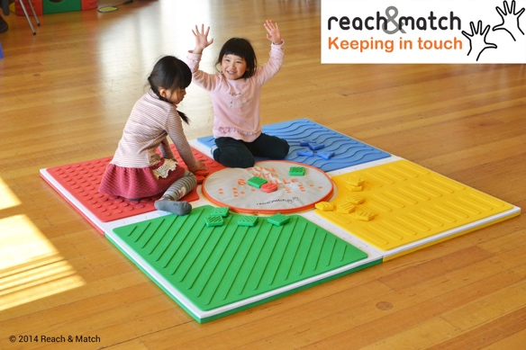
Reach & Match® is an award-winning inclusive kit for children with vision impairment and additional needs to learn braille and essential childhood skills with their peers in mainstream settings. It includes braille and print form for both vision impaired and sighted children to develop literacy and acquire early concepts of space & positional play, emotional development, motor, communication and social skills. The presentation will explain its research, unique features, applications and education values, and demonstration of Reach & Match will also help participants to understand how innovative and effective to apply Reach & Match in classes for their students with varying needs.

Reach & Match® Inclusive Learning Program is the result from collaborating with specialists and educators to develop 30 functional exercises and games based on 7 Learning Outcomes: Braille Learning, Cognitive Skills, Sensory Integration, Sense of satisfaction, Language Enrichment, Body Movement and Social Interaction. The design has received the Monash Vice-Chancellor's Social Inclusion Design Award, James Dyson Award and Red Dot Award etc. It is widely adopted at early learning centres, mainstream & special schools, universities, clinics and organisations in Australia and overseas.
Special Offer: 5% off & a FREE Activity Manual Email: mandy.lau@reachandmatch.com
Website: www.reachandmatch.com Facebook: https://www.facebook.com/reachandmatch/

Intended Audience
This presentation will be of value to educators, therapists and parents who work with children with sensory impairment and other special needs in mainstream and special schools.
Venue
RIDBC Renwick Centre, 361 - 365 North Rocks Road, North Rocks, NSW 2151 (SYDNEY)
Register online: Details will be available in early November 2015 on the website: http://www.ridbc.org.au/renwick/calendar-events
By faxing your registration form (02) 9873 1614
In Person: Royal Institute for Deaf and Blind Children
RIDBC Renwick Centre
361 - 365 North Rocks Road
North Rocks NSW 2151
8.00am to 4.00pm weekdays
Email our Continuing Professional Education Coordinator for further information trudy.smith@ridbc.org.au
Phone our Continuing Professional Education Coordinator for further information (02) 9872 0302
Copyright 2016 Royal Institute for Deaf and Blind Children

